MEXICO SCRAMBLING PROCESS OF CATCH UP AND GLOBALIZATION

CLEMENTE RUIZ DURÁN
UNIVERSIDAD NACIONAL AUTONOMA DE MÉXICO
JUNE 2018

MEXICO SCRAMBLING PROCESS OF CATCH UP AND GLOBALIZATION
During the last 50 years manufacturing value added in Mexico has multiplied almost by five, keeping its rank among industrial countries. But it has not been able to close the gap with large industrial economies like United States, in 1970 Mexico share of US manufacturing output was of 6 percent, today is only 10 percent, it could be argued that the catch-up process has been slow and erratic.
But how to explain the rising share of Mexico in export that was only 0.4 percent of world exports in 1970 and in 2017 were of 2.4 percent, reaching 409,404 million dollars, not that far from 573,694 million dollars of Korea, where the catch up process has allowed that its manufacturing value added per capita to be of 7,295 dollars, that is considerable above US value of 6,064 dollars.
The argument of this paper is that Mexico in the aftermath of the debt crisis was able to develop a large export platform but with low linkages with the rest of the economy, though it increased industrial capacity in the country allowing regional development in the country that led to a redesign of the geography.
- Getting out of the trap of natural resources
In the seventies in the aftermath of the oil crisis, Mexico pushed oil exploration and extraction, to finance the operation Federal Government contracted large volumes of debt under the assumption of high prices of oil, unfortunately that never happened due to the opening of alternative sources of oil in different countries in Asia (South East Asia and Europe North Sea). That brought in the debt crisis of the early eighties and the need to build up an export platform, that will not rely on raw materials, but on manufactured goods, to provide foreign exchange to the economy. As can be observed in graph 1, manufacturing exports vamped and put Mexico in the global value chains, today oil export share is of only 5 percent.

- Changing the manufacturing mix: linking to GVCs.
Getting out of the natural resource trap required the development of a new manufacturing platform, one that could support an export expansion in a steady way; the choice was to promote GVCs. Under NAFTA the main feature of manufacturing in Mexico was its location and wage differential with US and Canada. In the late nineties (1997) hourly compensation was of 2,62 dollars, compared with 23,04 of the States and 18,94 in Canada, that was a ten percent of US wages, and fourteen percent of Canada. This differential did not close overtime, in 2016 hourly compensation rose to 3,91 remaining to be the 10 percent of the US wage and 12 percent of Canada; in those terms Mexico promotion was to remain a stable low wage neighborhood within NAFTA, that was extremely attractive for many countries willing to export to the States through Mexico, as the case of German firms that hourly compensation was even more attractive as it was and remain to be nine percent of the compensation in manufacturing. GVCs that took advantage of the Mexican platform were transportation equipment manufacturing, computer and electronic product manufacturing, electrical equipment appliances and components, primary metal manufacturing, and chemical manufacturing (graph 2)
- New manufacturing mix with low investment coefficients
One of the main problems raised from the new manufacturing mix was that it was launched with low investment coefficients typical of in bond plants, that does not require a sophisticated network. There was a high reliance on foreign investors, in the period 1999 to 2017, funds for manufacturing plants in Mexico were around 244 thousand million dollars, mainly in transport equipment, electronics, computers, chemical and beverage manufacturing. Overall investment coefficient was of 21 percent of GDP and the manufacturing investment coefficient was only of 4 percent of GDP.
- Employment and productivity effects of the new manufacturing mix
New manufacturing platform created 1,333,744 new jobs in the period 1990 to 2016, which came mainly from the transportation equipment manufacturing (52 percent) and from the computer and electronic product manufacturing (33 percent). One interesting feature in this process was the raise of the level of education of the manufacturing employees; there was a reduction of 37 percent in basic education posts, a large increase in intermediate education and small increase in higher educations posts that were contracted by the transport and computer and electronic product manufacturing.
When this is paired with value added it could be observed, that growth of productivity per worker increased, but wages increased at a lower rate, so it could be argued that there is paradigm of higher skill combine with low wage manufacturing as Anderson and Holmes (2007) points out “there is a perceived duality between high-wage/high skill and low-wage/low skill industrial strategies underlies many accounts of contemporary industrial change. Within some North American manufacturing sectors a hybrid strategy has taken root, one that combines technologically sophisticated product and process innovation with low-wage production” This sort of behavior has been the underlying force of free trade agreements, and also has been the driving force of global value chains.

- Platform and cluster development: creation of innovation ecosystems
One of the main features of manufacturing restructuring was that it was led by different forces: on the macro level the stimulus came through the cost mechanism of low wage paradox, with an improvement of the education level. What is interesting is that promotion of investment, did not came from a sophisticated central office, but rather by a mix of federal and state level promotion. Debt crisis pushed federal government to promote state and local government support for the promotion of industrial clusters. This process became official with the creation of a Board of State Governors Conference (CONAGO) in 2002. This process led to the emergence of planning process at State level. Governors became active agents for promoting planning and one of the main features was that they became responsible to develop business environment and attract foreign investors into their territory, in some cases they were supported by a long-term planning i.e. the State of Guanajuato had a strategic program up to 2040, and the State of Jalisco up to 2032.
Institutional development led to a broad policy of promotion to attract foreign investors through a policy of land use, supported by infrastructure development in industrial parks; businessmen created the Association of Industrial Parks that today hosts more than 538 parks in the country, that has enabled new financial tools to promote new developments as is the case of the trust funds for industrial real estate denominated FIBRAS, and special funds managed by State governments.

This policy mix led to an uneven process of promotion in the regions, where Federal, State and local governments became involved, with the participation of local businessmen to promote foreign investors into their territories. This sort of policy was successful attracting investments in transport equipment, computers and electronics devices, chemical and pharmaceutics, among others. The whole process was developed by stages and by regions. In the first phase came in the Northern Border States where electronics took advantage of the Tijuana/ San Diego border crossing point for electronics and electro domestic, next was the auto industry in Sonora and Chihuahua (Ford Corporation) Chrysler took advantage of Nuevo León and developed the Coahuila network, that latter combined the Daimler Benz operation and GM, this was at the last decades of the 20th Century. Border states led exports with 50 percent of total.
Second wave of investment developed in the Western Central area, where the aim was to push new industries, Guadalajara became the pioneer in the digital-electronic industries, led by IBM and Hewlett Packard, promoting digital businesses that led to creative industries, and also embedded software developments linked to the auto industry . This attracted the Japanese to set up a Honda Plant for exports and in the neighboring state of Aguascalientes led by Nissan one of the largest network was developed in different stages, Guanajuato vicinity attracted Toyota, Mazda, Volkswagen. Economies of scope led to develop auto parts industries also in Querétaro and San Luis Potosí, where not only auto industries were developed, but also the Canadian Bombardier set up an assembling plant, BMW is building a very large facility for the new series 3 cars, domestic complex was build there with national business that attracted later to Samsung to the region. All the process led to a coprosperity area, growing at 5 percent a year, well above national growth.
Third area of clustering was the traditional industries platform, in the vicinity of Mexico City and the neighboring states, here was the first auto industries installed, some of them move to the North, but some others refurnished their facilities, i.e. Ford corporation transformed its Cuautitlan plant from traditional fuels operation to the new generation of electric cars, Nissan in Cuernavaca is assembling the New York City taxis, Volkswagen and Audi had developed new facilities in Puebla. Mexico City has attracted also large pharmaceutical and medical device corporations, combined with research developed in the University Centers of Mexico.
Clustering led to a density process that pushed innovations and interactions among regional suppliers, all this brought in economies of scope at different levels and modalities. In the western central area of Mexico interactions increased among relatively medium size cities, pushing for a new sort of economic development, giving birth to interactive cities, that instead of increasing in size took advantage of economies of scope that allowed them specialization in different segments of the industry. What seems interesting is that clustering went beyond traditional agglomeration, and brings in the new geography of cities and they interaction with other cities. As Storper states: the proximate cause of divergence and turbulence is to be found in changes in specialization, reflecting different levels of creating or absorbing innovative activities. Clustering was a disruptive process that required an environment of innovation, for that purpose there was a demand for technical schools and universities, that in some cases were accompanied with the emergence of research centers. Some key industries took advantage of the knowledge network that was developed, as has been the case of Mabe (an electro domestic producer) that instead of creating a research area within the company decided to interact with local universities in Querétaro and San Luis Potosí to introduce innovations into the production line.
University expansion had followed a continuous path as can be observed in table 3, however links have been very loose and very few experiences have followed this path, in a sense idle capacities are lying in the knowledge network, due to the fact that the universities and business have been unable to take advantage one from the other, this has reflected in the low patent registration in the country. Agent convergence have not been able to develop due to institutional problems, there is no guidance at Federal, State or local governments to support linkages. There is no need of further expansion of the educational networks, but rather what is required is the need for further interactions, that could be obtained only with a guidance system that could support this process, today the Science and Technology Agency (CONACYT), has no power to bring together the expertise into the enterprises, reforms are required to push the process.
University networks has become the core of knowledge in the regions, but have not pushed innovation on large scale. Isolation of the university networks from the business communities reflects in the low rate of patent registration, very few of them register patents. Central Mexico, Border States and Western Central States are ones with larger patents. Behind this process there is also a bureaucratic problem of the cost of registering patents, as pointed out by Vega González and Hernandez Jardines “costs that were incurred to obtain two national patents were quite significant, but much more in the case of patent applications abroad, either by direct application or through the Patent Cooperation Treaty (PCT)”. Innovation is not homogenous; there is a correlation between clusters development and patent registration, the higher the business concentration there is a higher probability to have a registration of patents. As shown in table 4, concentration is higher in Central Mexico, where 657 patents were registered in 2017, followed by Border States and Western Central States, the rest of the country has low rate of patent registration. Though in some cases agribusiness are pushing innovation, as is the case of Sinaloa where there is large investment in greenhouses and river development, they have registered algal blooms as biofuel for agricultural needs.
Industrial upgrading and effects over the economy
Analysis of the Input – Output tables in the manufacturing sector was realized to estimate the largest multipliers effects over the economy and from there to choose the manufacturing activities that have a larger effect over the economy in the period, the effect was that there was larger multipliers in industries focused on the domestic market – food industries in GVP and textile industries in employment, and lower multipliers in export industries.

A question that rises is: if the big transformation of Mexico was based in creating an export platform, why the export industries has such a bad performance in terms of employment and gross value of production? It could be argued that domestic linkages are very low, in terms of export value added all coefficients are below 30 percent, as can be observed in table 8, the highest coefficients are in transportation equipment manufacturing, primary metal manufacturing and machinery manufacturing. This low value added shows that the export platform that Mexico has developed has been unable to capture a more dynamic linkages with the rest of the economy, changes in the last 13 years has been small, except in the transport equipment manufacturing where it has doubled in the period, due to the opening of auto parts manufacturing.
- How GVCs has increased the density of Mexican manufacturing?
Above discussion shows that GVCs development has not been able to develop an increased value added into the economy, though it has provided density to the manufacturing sector in Mexico. A complex process of learning with large inequalities has been brought into the sector, it has not followed the same pattern as the case of other developing economies, rather it has adapted to multinational patterns, combined with structure of local governments, that has been thought how to develop tools to promote local suppliers, rather than increasing imports from abroad. Following paragraphs includes detailed examples of how this GVC has been able to develop linkages within the Mexican economy, all of the cases are dynamic and innovative, transportation has gone from traditional vehicles, to the production of non gasoline cars, electronics have allowed Mexico to become partner in the semiconductor adventure that is reshaping the world economy and finally the pharmaceutical and medical devices is allowing Mexico to become competitive in the health economy.
- Auto industry.
In 2015, Mexico produced 3.4 million motor vehicles and occupied seventh place among vehicle manufacturers globally. This level of output was twice that of 2005, when Mexico was tenth largest producer in the world. This surge is the result of large investments by international automotive and auto-parts companies that, according to the Ministry of the Economy, reached around 20 billion dollars between 2013 and 2015. Global automotive producers’ relocation of production facilities to Mexico has been influenced by the country’s membership of the North America Free Trade Agreement (NAFTA), its highly skilled labor force and low wages. Mexico’s upswing has not yet reached its end. The country is projected to be the world’s fifth largest producer of vehicles by 2020. The federal government has launched a Strategic Programme for the Automotive Industry 2012–2020, which seeks to combine strategies and policies to make Mexico one of the top three preferred locations worldwide in car assembling and component production. While much of this dynamic should come from exports, the government plans to broaden the domestic market for vehicles with more technology to support the green economy. Value chain developed up today is shown in the diagram.

- Electronic Sector in Mexico
The electronic sector focuses on devices or components that process some type of information. This industry is divided into five major sub-sectors: audio and video, computer and office, semiconductors, communications, and medical equipment and precision, measurement, navigation, control and optical instruments. In 2016, Mexico positioned itself as the 8th largest electronic producer in the world and 1st in Latin America. In 2016, the production of the sector in our country was higher than the 77,520 million dollars, with which the sector contributed with 5.3% of manufacturing GDP and 1.5% of GDP.
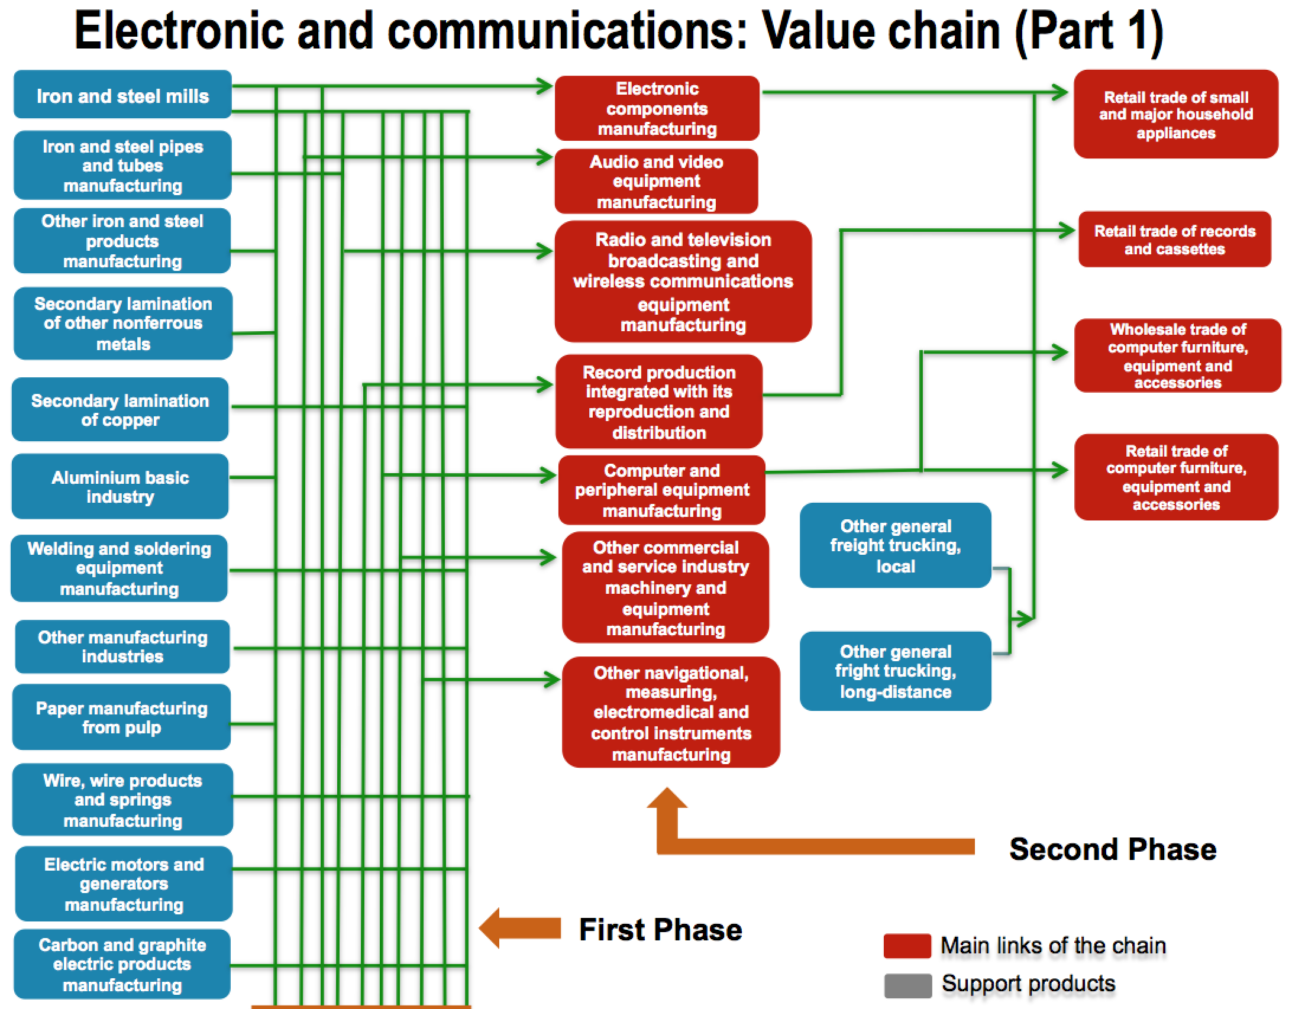
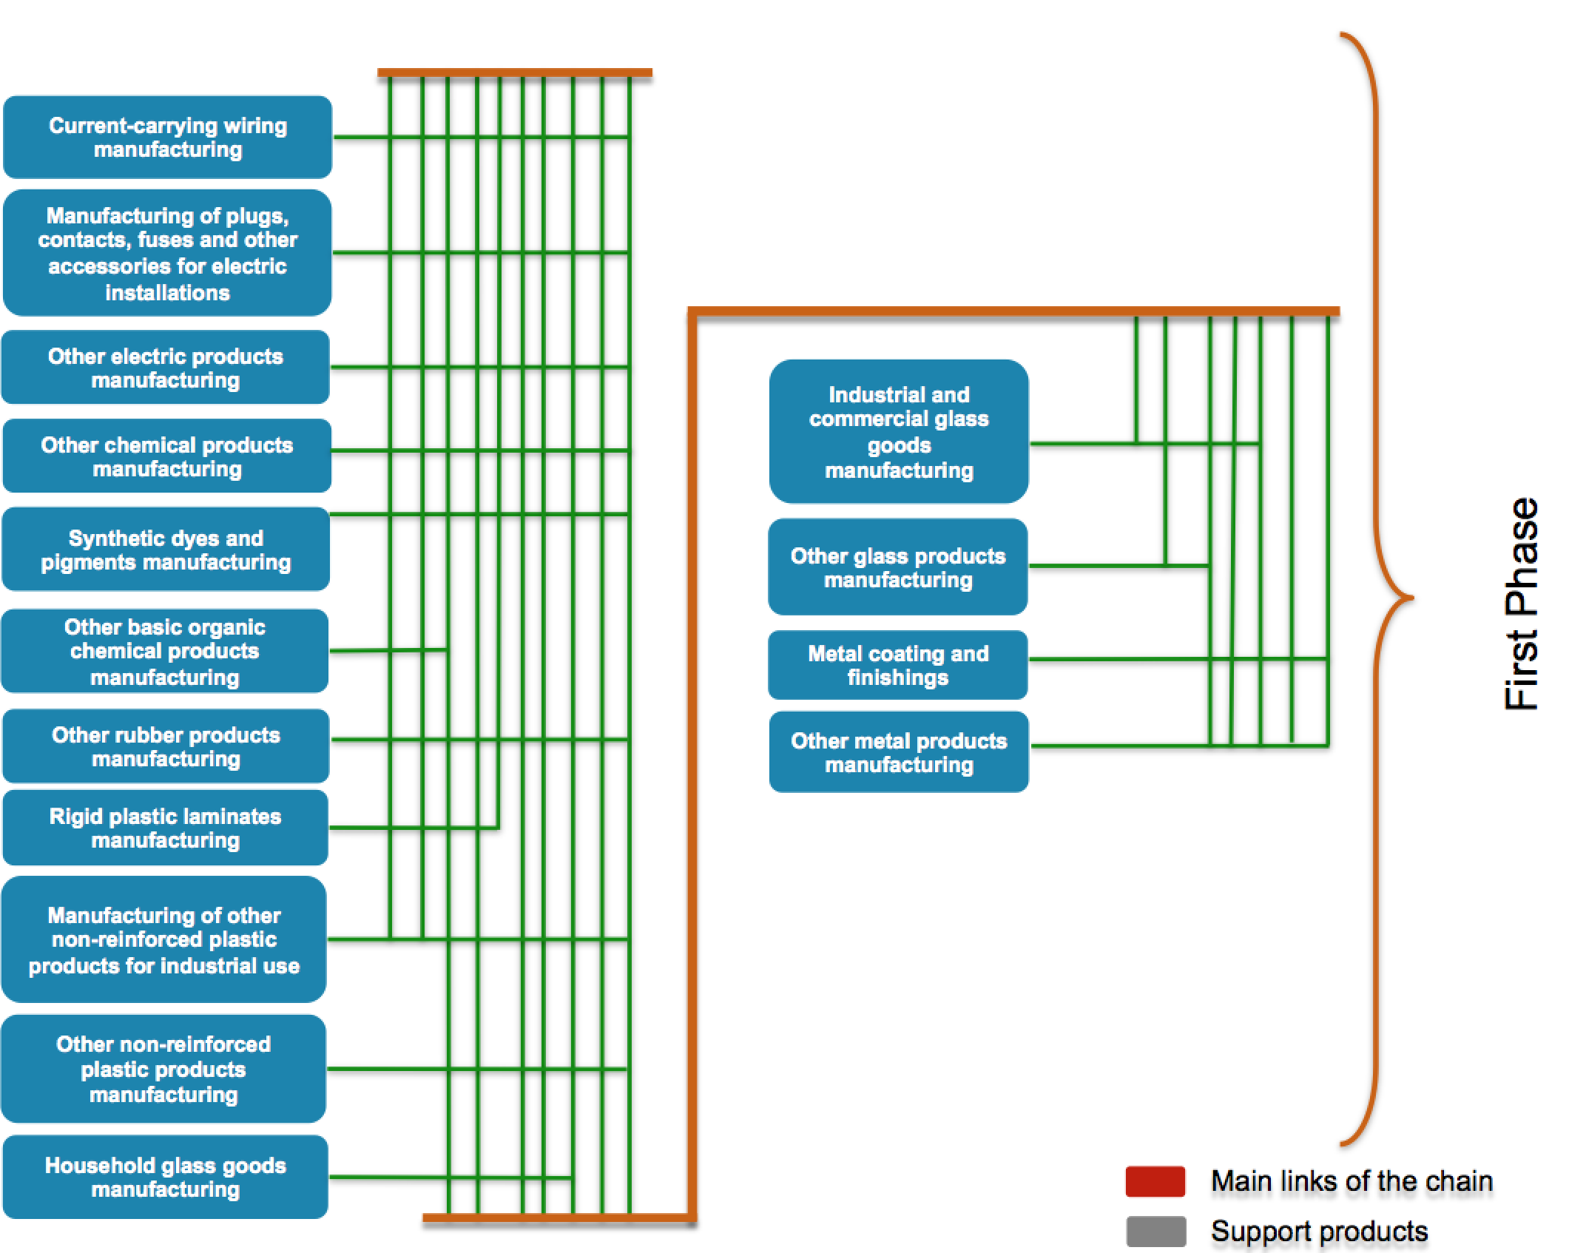
- Pharmaceutical Cluster.
Industry production is US$14,283 millions, with foreign investment of around 3,172 millions; local consumption is around US$17,612 millions, exports of the pharmaceutical industry reached 1,847 millions and employment is around 59,650 employees. Mexico has become an attractive destination for investment in the pharmaceutical industry due to an improved regulatory framework and to the increase in quality certifications, foreign companies are Merck Sharp Dome, Boehringer Ingelheim, Schering Plough, Bayer, AstraZeneca, Pfizer and GlaxoSmithKline
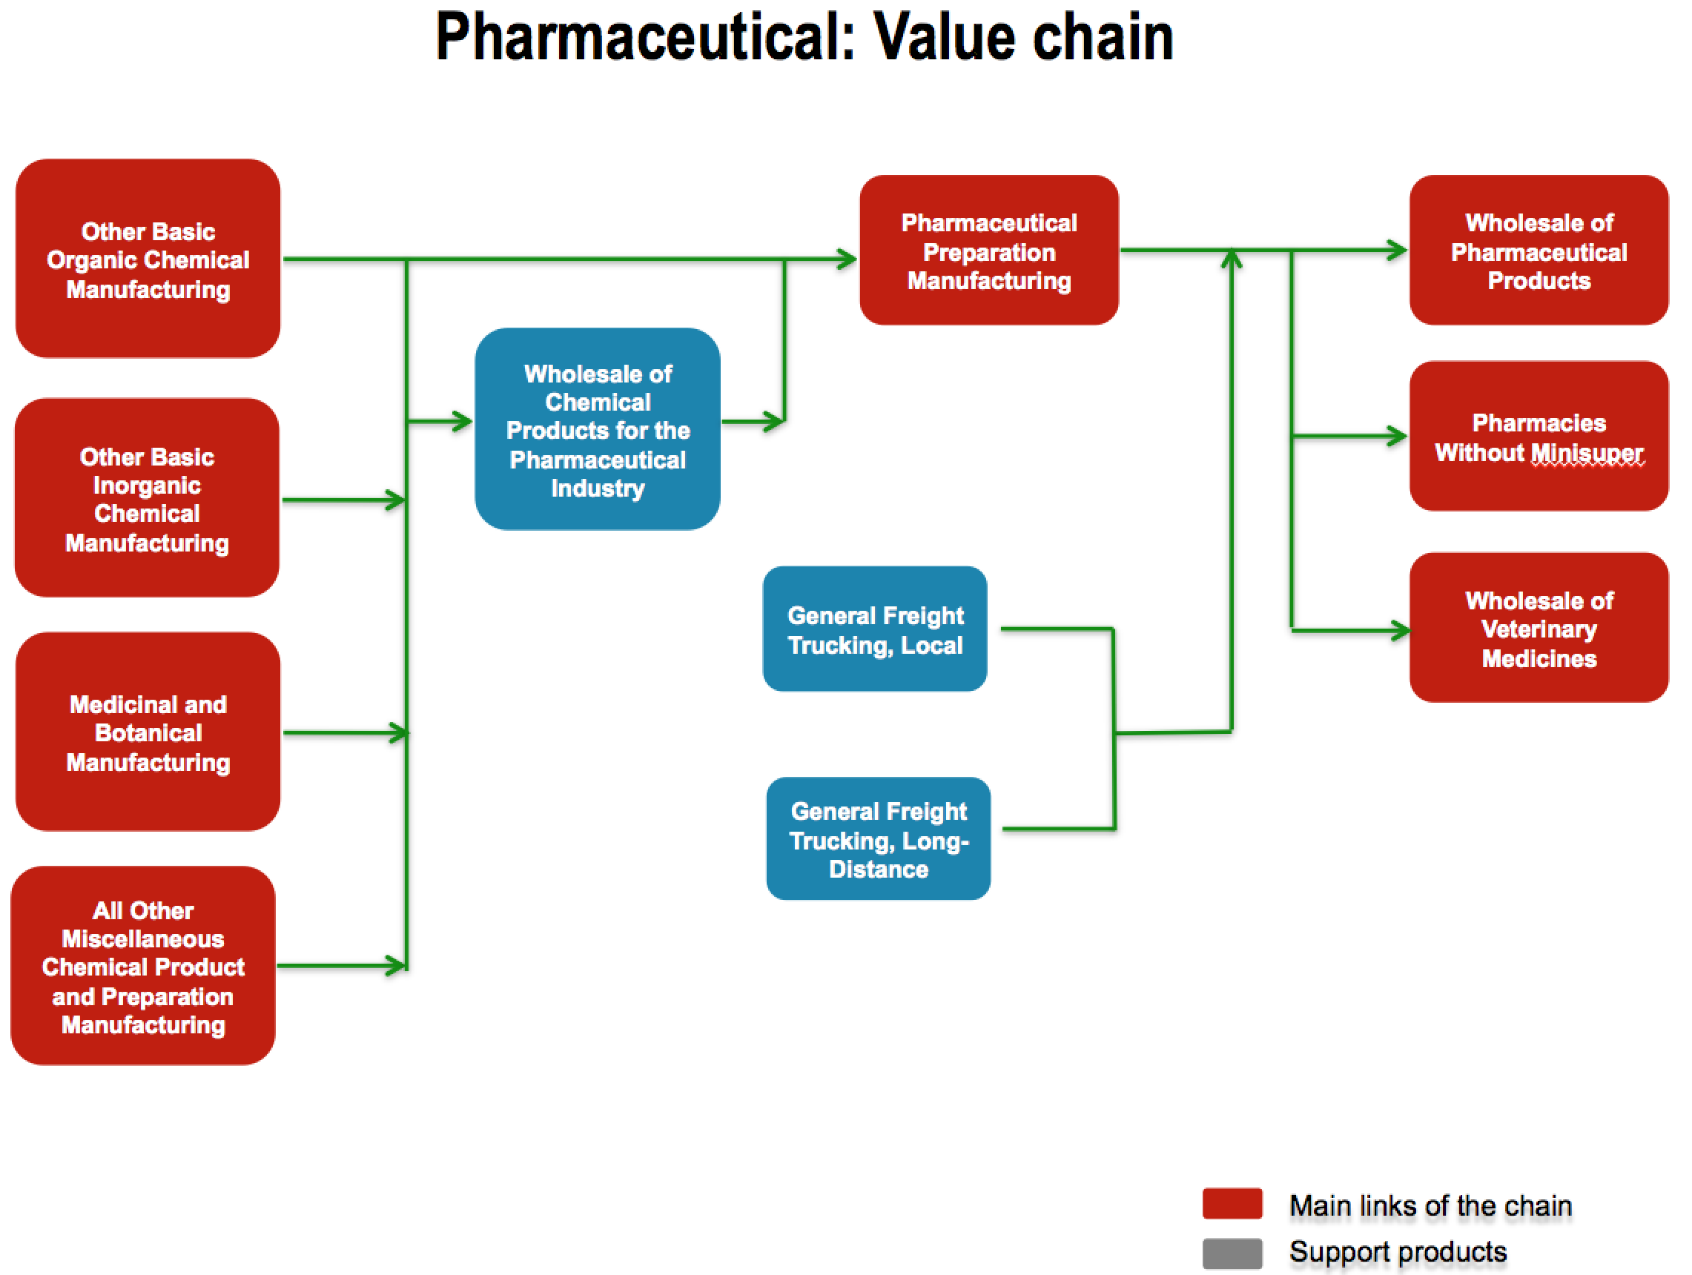
- Medical Devices,
Mexico is the world´s 8th largest exporter and the US main provider of medical devices as well as the first exporter in Latin America; third exporter in the world of tubular suture needles; fourth exporter of medical furniture, such as stretchers and operating tables; fourth exporter of needles catheters, cannulas and similar instruments. Main producers are Medtronic, Johnson and Johnson, General Electric, Siemens, Becton Dickinson, Cardinal Health, Philips, and Baxter must of them are located in Jalisco
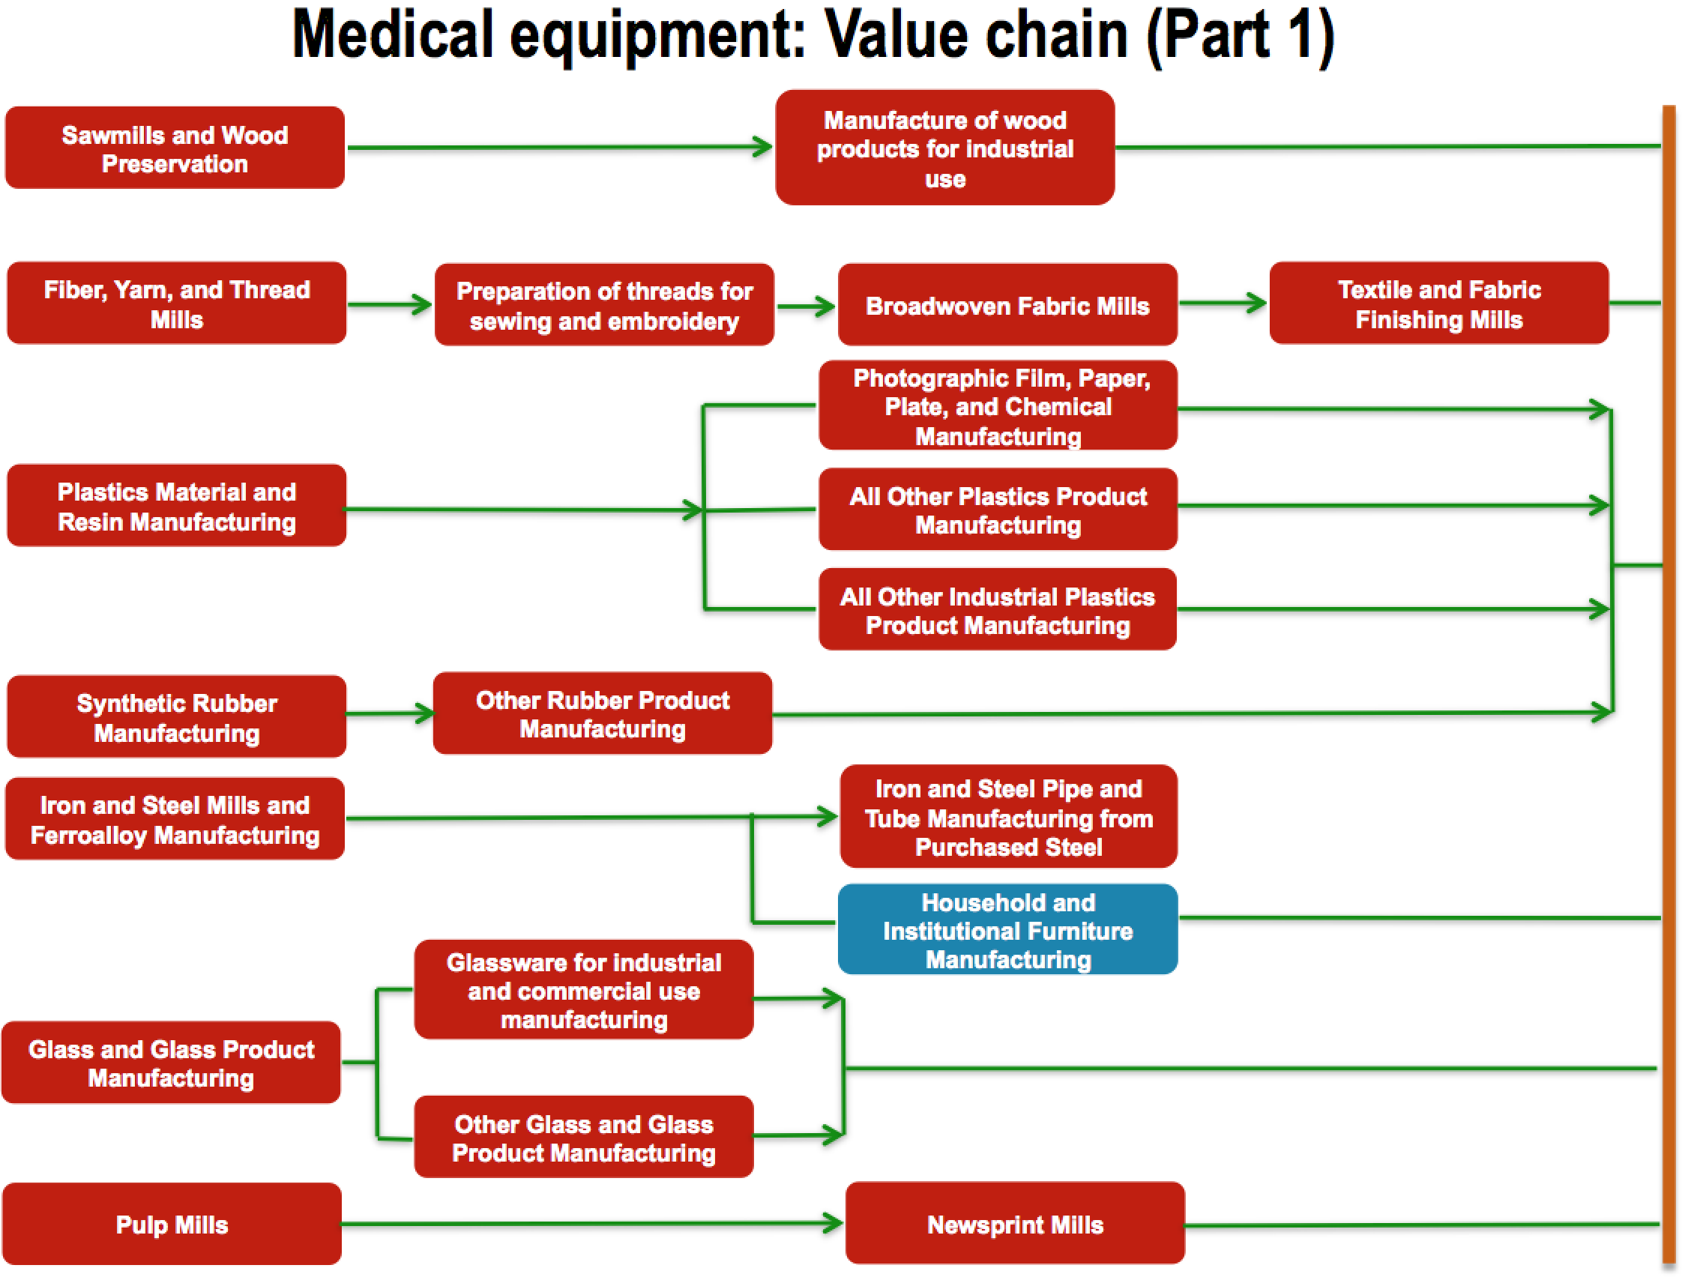
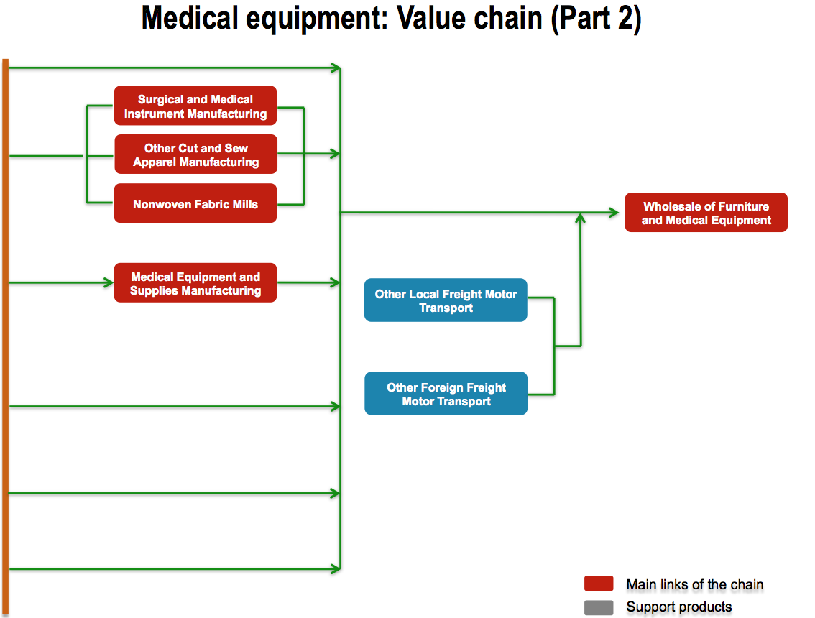

- Institutional framework and the catch up effect
Mexican experience reflects clearly the middle-income trap dilemma, today is the 15th economy of the world, but unable to move upwards. The Latin American experience demonstrates clearly that government leadership without mechanisms that simulate competition in protected domestic markets does not generate sustained productive transformation. But primary reliance on market forces without strategic government support for growth-enhancing structural change does not generate dynamic comparative advantages. The last 30 years in Latin America have shown that: (a) relying primarily on market forces cements static comparative advantages, but does not lead to broad development of higher value added activities, (b) securing access to developed country markets through trade agreements may lead to greater integration into GVCs, but – by itself – does not call forth upgrading in production, (c) encouraging foreign direct investment (FDI) with special incentives and bilateral investment treaties may indeed attract more FDI, but FDI per se does not generate significant linkages with the rest of the economy or engender technology transfer. (d) domestic innovation capabilities do not develop without pro-active government policies at the meso, micro, and macro level. To avoid being trapped at the middle-income level, the development strategy for middle income countries has to focus squarely on the promotion of domestic innovation capabilities in a systemic way. The implementation of such a strategy requires a renewed focus on active policies for productive transformation, for greater innovation in existing sectors and in support of a reallocation towards higher productivity sectors. The large heterogeneity in capabilities and productivity among domestic firms means that the incorporation of knowledge developed elsewhere will continue to be important to increase productivity for many firms and to reduce the large productivity gaps among firms. Yet, it is more domestic creation of innovation that will be particularly important for moving forward. Innovation has to be a collective process where public and private actors interact and collaborate, initiatives have to complement each other, and the macro and micro incentives have to support innovation rather than discourage it. Local firms develop capabilities by learning in the production process and through internal R&D efforts as well as through interactions with other key actors in the economy: other domestic firms, foreign firms, research institutions, and universities. The meso and macro contexts have to make learning-by-doing at the micro level possible. That means that social capabilities have to evolve so that firms have the requisite information about technology and markets, have access to funding and the needed qualified personnel, and possibilities to collaborate with other firms or research entities in the innovation process. And the relative price and support structure has to be such that it makes the risk-taking of innovation not only possible, but also necessary.
The pervasiveness of coordination failures, capability failures, and market inadequacies as well as the need for non-marginal changes demand a pro-active state for the achievement of broad-based upgrading. Horizontal and vertical policies are needed to advance social capabilities, support the development of local firm capabilities and establish a critical level of absorptive capacity, enable TNC affiliates to upgrade production in the host country towards more sophisticated activities, and provide a set of economic incentives conducive to broad-based capability accumulation.

Bibliography
- Bryson J., Clark J., Vanchan V. (2015) Handbook of Manufacturing Industries in the World Economy. Edgar Elgar

- IMF (2018) Cyclical Upswing, Structural Change World Economic Outlook April 2018.

- IMPI Database

- INEGI Input Output Matrix 2008 - 2013

- OECD Statistical Database

- Paus Eva (2017) Escaping the middle income trap: innovate or perish. ADBI Working Paper Series No. 685 March 2017.
www.adb.org/sites/default/files/publication/231951/adbi-wp685.pdf

- Szirmai A., Naude W, Alcorta L. (2017) Pathways to industrialization in the 21 Century. Oxford Economic Papers

- Woo-Cumings (1999) The Developmental State. Cornell University Press

- UNCTAD Database

- UNIDO Database

I thank Elias Sosa for his support for the current research
Anderson M and Holmes J. “High-skill, low wage manufacturing in North America: a case study from the automotive parts Industry” Journal of Regional Studies 29:7 655-671
https://www.routledgehandbooks.com/doi/10.4324/9780203387061.ch3 Nobuya Haraguchi (2015) Patterns of Structural Change and Manufacturing Development Routledge Handbook of Industry and Development
Storper M. (2018) Regional Innovation Transitions.
L.R.Vega-GonzálezaI.J.Hernández-Jardine (2017) “The costs of patenting in Mexico” Revista Médica del Hospital General de México

